**To Supply Leftover Food to the Poor**

# Project Overview

* This project aims to tackle two pressing global challenges: food wastage and hunger. Every day, significant amounts of food go unused and end up in landfills, while millions of people struggle with food insecurity. Our initiative, powered by Salesforce, seeks to create a robust platform to collect leftover food from donors such as restaurants, event organizers, and households, and redistribute it to underprivileged communities. The goal is to ensure that surplus food is not wasted but instead becomes a resource for those in need.
* The platform will streamline the donation process by providing a centralized system where donors can log surplus food items, which are then matched with recipients based on real-time needs. Key features such as automated workflows, notifications, and integration with mapping tools will ensure timely food pickup and delivery while minimizing spoilage. The system will also generate dashboards and reports, enabling stakeholders to monitor and analyze the program's impact, including the number of meals served and the volume of food waste reduced.
* By leveraging Salesforce’s capabilities, this solution not only addresses immediate food security concerns but also fosters long-term sustainability. It emphasizes the importance of utilizing technology to create a bridge between food abundance and scarcity, ensuring that no one goes to bed hungry while surplus food is wasted. Additionally, it raises awareness about responsible food management and promotes community participation to build a more equitable and sustainable future.

# Objectives

### Business Goals:

* + Reduce food wastage by creating an efficient system for collecting and redistributing leftover food.
  + Address hunger and food insecurity in underprivileged communities by ensuring surplus food is repurposed effectively.
  + Foster partnerships with food donors, volunteers, and NGOs to build a sustainable food redistribution network.

***Specific Objectives:***

## Develop a Centralized Platform:

Create a Salesforce-based system to log, manage, and track surplus food donations from restaurants, event organizers, and households.

## Enable Real-Time Operations:

Implement real-time notifications and workflows for food collection, delivery, and allocation to minimize spoilage and maximize impact.

## Ensure Transparency and Accountability:

Generate dashboards and reports to monitor the initiative’s reach, including metrics such as meals delivered, food waste reduced, and areas served.

## Promote Community Participation:

Encourage greater community involvement by creating easy-to-use portals for donors and volunteers, fostering a culture of sharing and sustainability.

## Optimize Logistics and Distribution:

Integrate mapping tools for route optimization to streamline food pickup and delivery processes, ensuring timely redistribution to high-need areas.

By achieving these objectives, the project will contribute to a more equitable society, where technology helps transform surplus into sustenance for the needy.

# Salesforce Key Features and Concepts Utilized

## Custom Objects and Fields

* + Custom objects to represent **Donors**, **Food Items**, **Recipients**, and

## Logistics.

* + Fields to capture essential details, such as food type, quantity, expiration date, donor contact information, and delivery status.

## Process Automation

* + Workflow Rules and Process Builder for automating notifications to venue and donors.
  + Approval Processes to validate large-scale donations and ensure food compliance.

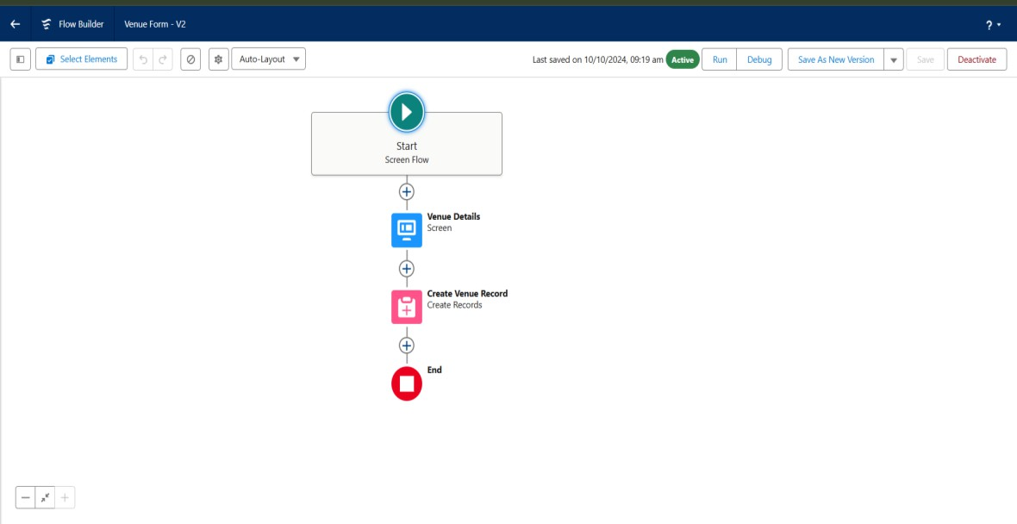

## Dashboards and Reports

Dashboards and reports in Salesforce will play a crucial role in providing real-time insights and transparency into the operations of the food redistribution initiative. These tools will enable stakeholders to monitor progress, measure impact, and make data-driven decisions to optimize the system further.

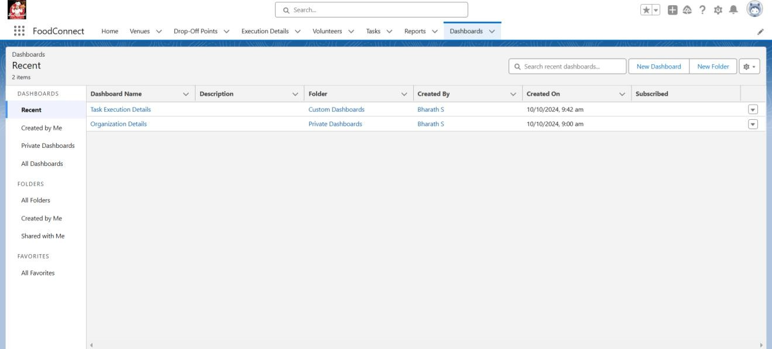

**DASHBOARD**

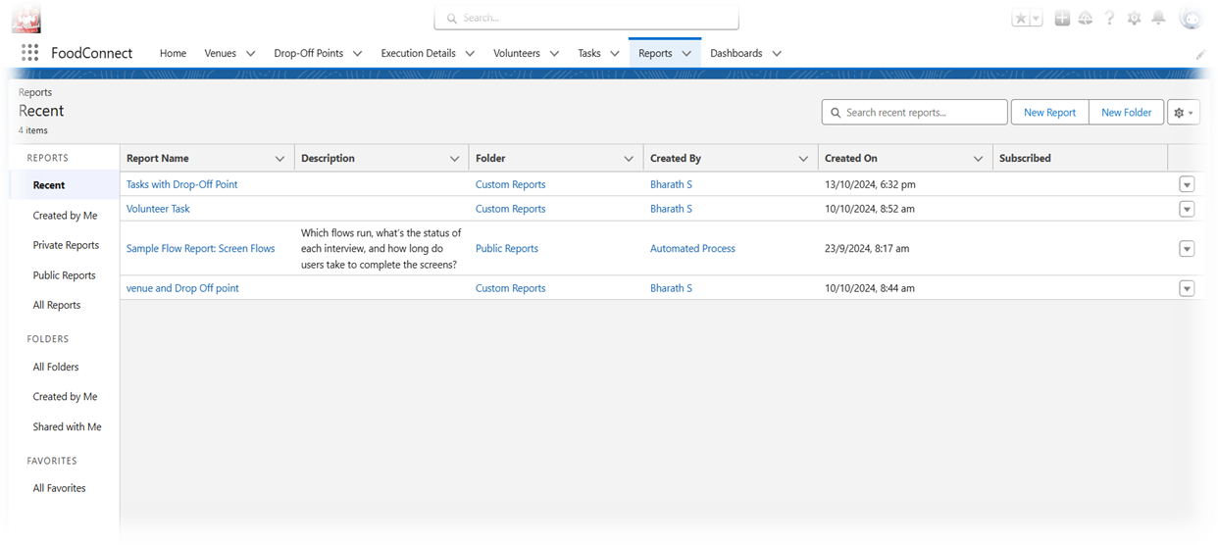

**REPORT**

1. **Donation Tracking Dashboard:**
   * Displays the total number of donations received daily, weekly, and monthly.
   * Highlights donor activity trends, including top donors and peak donation times.
   * Tracks food categories (e.g., perishable vs. non-perishable) for better planning.

## Food Distribution Dashboard:

* + Monitors the number of meals delivered to recipients over time.
  + Maps distribution coverage to identify underserved areas.
  + Tracks pending deliveries and on-time delivery rates.

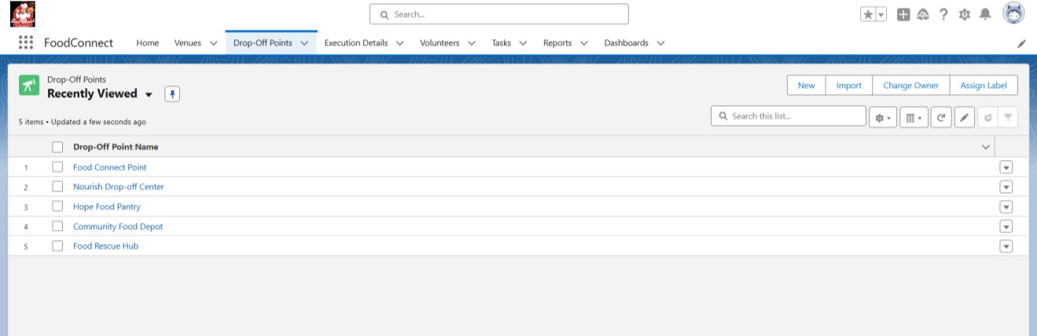

**DROP-OFF POINT**

## Volunteer and Logistics Dashboard:

## The Volunteer and Logistics Dashboard serves as the operational backbone of the initiative, seamlessly integrating the efforts of donors, volunteers, and logistics coordinators. Key features include dynamic task allocation, where volunteers are automatically matched with food collection and delivery tasks based on their location and availability, and a real-time vehicle tracking system to optimize resource utilization.

* + Tracks volunteer participation rates and task completion status.
  + Monitors vehicle utilization and delivery efficiency.
  + Provides insights into logistical bottlenecks for route optimization.
  + Tracks spoilage rates to improve workflows and storage practices.

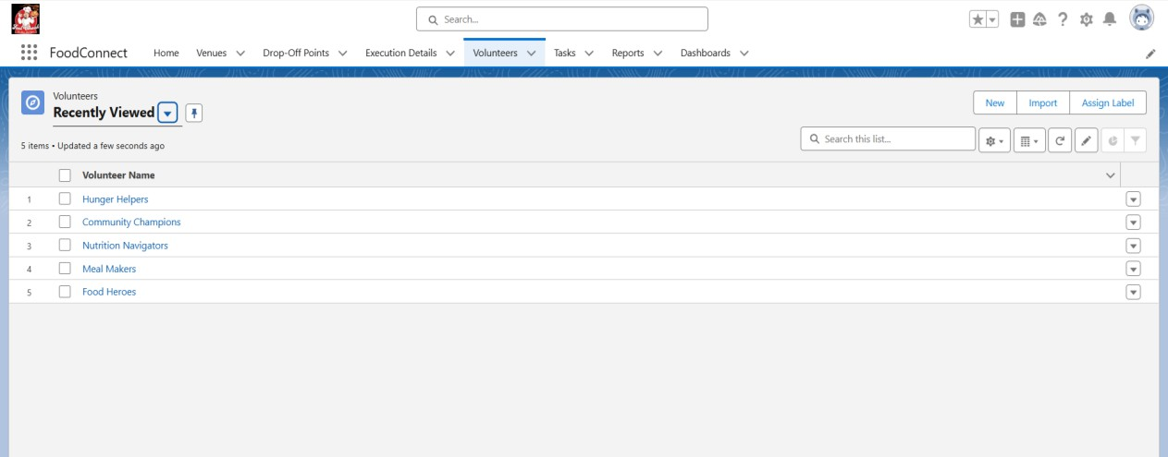

**Volunteer Dashboard**

# Detailed Steps to Solution Design

## Lightning App:

* The Lightning App for the "To Supply Leftover Food to the Poor" project will be developed within the Salesforce ecosystem, providing an intuitive, user-friendly interface that will enable stakeholders (venue, Drop-off point, volunteers, and administrators) to efficiently manage the food redistribution process.

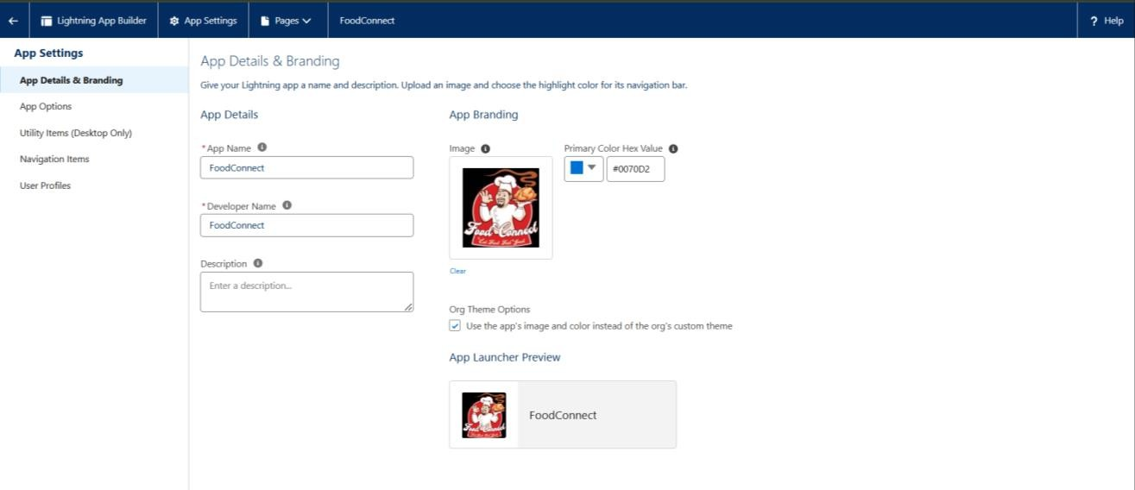

**Lightning App Builder**

## App Layout and Navigation:

1. **Home Tab:** A dynamic dashboard showing high-level metrics like the number of meals donated, total food collected, and delivery status.
2. **Venues:** Venues include restaurants, event venues, community centers, and households, where donors can drop off surplus food for redistribution.
3. **Drop-off points:** Drop-off points are designated locations where donors can leave food, and where volunteers can pick up donations for delivery to recipients.
4. **Execution Details:** Execution details involve managing the collection, transportation, and distribution of food through scheduled pickups and timely deliveries by volunteers.
5. **Volunteers:** Volunteers can view upcoming delivery tasks, track their assigned routes, and log delivery statuses.
6. **Tasks:** Tasks include logging donations, scheduling pickups, delivering food, and updating the system with status reports on food collection and delivery.

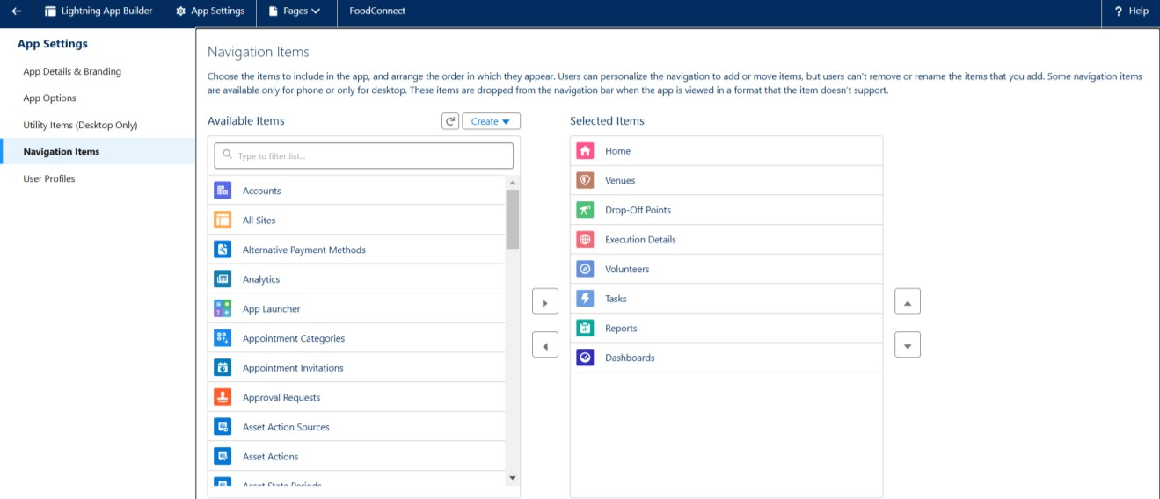

**Navigation Item**

**Home Tab**

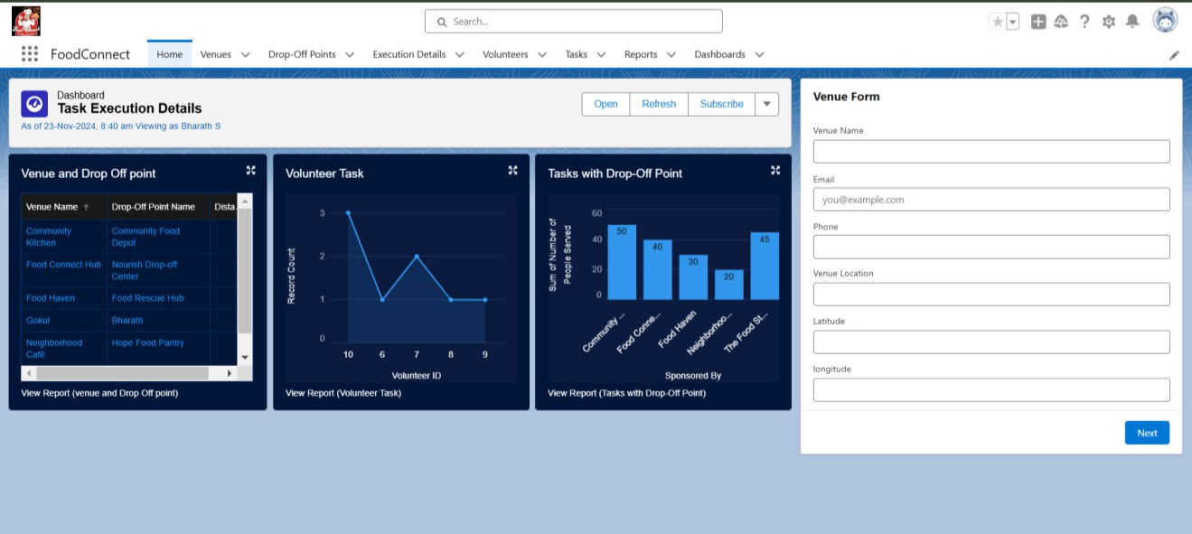

## Workflow Automation:

* Workflow automation is a critical component of the initiative, designed to ensure seamless coordination between donors, volunteers, and recipients while minimizing manual effort and errors.
* Using Salesforce’s advanced tools such as Workflow Rules, Process Builder, and Flow Builder, the system automates key processes, enabling faster response times and improved operational efficiency.
* For instance, when a donor logs a surplus food item, automated workflows instantly notify the nearest volunteers and assign them collection tasks based on availability and proximity. Similarly, automated alerts are sent to recipients, providing updates on expected delivery times.

.

## Integration

* Integration plays a pivotal role in creating a seamless and efficient system for the "To Supply Leftover Food to the Poor" initiative, leveraging technology to connect various stakeholders and optimize processes.
* The system integrates with advanced mapping tools such as Google Maps or similar geolocation services to facilitate route optimization for pickups and deliveries.
* This ensures that food donations are collected and distributed in the shortest possible time, reducing transportation costs and spoilage.
* Furthermore, integration with external food safety compliance systems ensures that donated food meets required health and safety standards before distribution, fostering trust among recipients and donors.

# Testing and Validation

## Unit Testing:

* + Unit testing forms the foundation of the validation process, focusing on the individual components of the system to ensure their functionality and reliability.
  + This involves testing custom Apex classes and triggers developed within Salesforce to handle specific processes, such as donation requests, food allocation, and logistics management.
  + For instance, each trigger is rigorously validated to ensure that food item records are updated correctly in response to status changes, and that workflow automation operates as intended without errors.
  + Additionally, the integration of mapping APIs is tested to verify accurate route calculations and geolocation-based task assignments**.**

## User Interface Testing:

* + - * User Interface (UI) testing ensures that the platform is intuitive, accessible, and responsive across various devices and user groups, including donors, volunteers, and administrators.
      * This involves evaluating the portals for usability, ensuring that each interface element—such as dashboards, forms, and navigation menus—is easy to understand and interact with.
      * Volunteers should be able to view assigned tasks, update their statuses, and access route maps without confusion, while donors should easily log surplus food items and track pickup schedules.
      * Simulations are conducted to validate the platform’s responsiveness on multiple devices, including smartphones, tablets, and desktops, ensuring a consistent user experience regardless of screen size or resolution.
      * Additionally, accessibility features are tested to accommodate users with disabilities, such as keyboard navigation and screen reader compatibility.

## End-to-End Testing:

* End-to-end testing validates the complete workflow of the system, ensuring that all integrated components work together seamlessly from start to finish.
* This comprehensive testing phase involves simulating real-world scenarios where donors log food items, volunteers are notified and assigned tasks, food is picked up and delivered, and recipients confirm delivery.
* The focus is on identifying and addressing any gaps in the process, such as communication delays, routing inefficiencies, or mismatched task assignments.

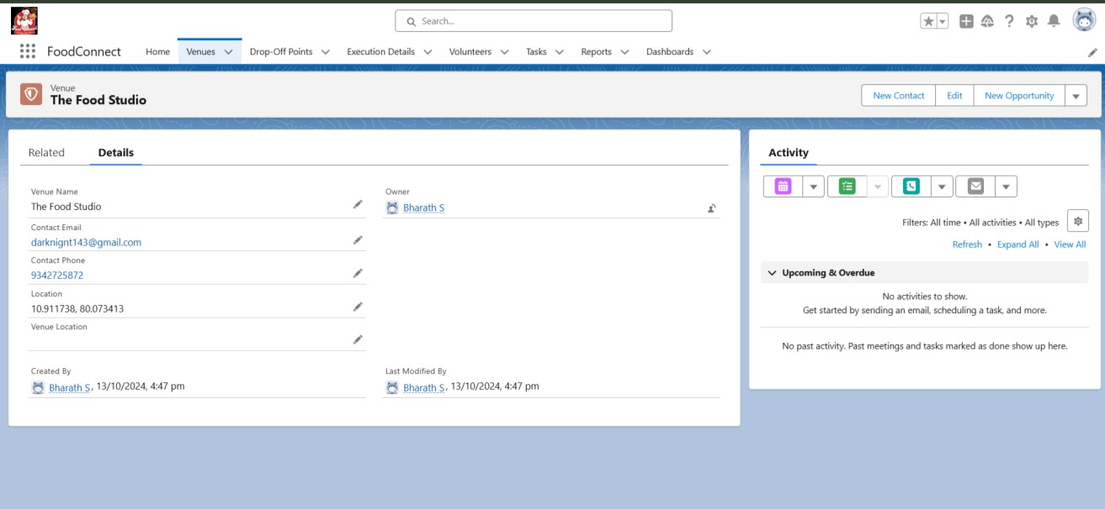

End-to-end testing ensures the entire system operates seamlessly by validating complete workflows. The key aspects of this testing phase include:

* **Full Workflow Simulation**:
  + Test the entire process from donor food item logging to volunteer task assignment, pickup, and recipient delivery.
  + Validate the integration and interaction of all components.
* **Real-World Scenarios**:
  + Simulate typical cases, such as food pickup from donors and delivery to recipients.
  + Account for traffic delays, route changes, or last-minute modifications in recipient locations.
* **Dynamic Adjustments**:
  + Verify the system's ability to adapt to real-time changes in logistics, such as

vehicle unavailability or rerouting due to emergencies.

* **Error Handling and Fallbacks**:
  + Test edge cases, like overlapping volunteer tasks or cancelled donations, to ensure proper error notifications and recovery mechanisms.
* **Stakeholder Engagement**:
  + Involve donors, volunteers, and recipients in pilot testing to identify gaps and collect feedback for improvements.
* **Performance Metrics Validation**:
  + Ensure key metrics like delivery success rates, average response times, and spoilage reduction are accurately tracked.
* **Error Handling and Recovery**:
* Evaluate how the system manages critical issues like food spoilage, delivery mismatches, or technical failures.
* Ensure fallback mechanisms and error alerts are implemented effectively.
* **System Scalability**:
* Validate the system's performance under high-volume scenarios, such as large-scale donations or simultaneous task assignments for multiple volunteers.
* Ensure the platform can handle peak loads without lag or errors.

By addressing these aspects, end-to-end testing ensures that the platform can manage real-life complexities, offering a smooth and reliable experience. With these additional testing topics, the system will be thoroughly vetted to ensure it operates reliably, even in complexed..

**Key Scenarios Addressed by Salesforce in the Implementation Project**

### Handling Large-Scale Donations:

* Managing large-scale food donations, such as those from weddings, corporate events, or festivals, can be a complex challenge, especially when dealing with the logistics of timely delivery and proper utilization.
* The food surplus from these events may vary in size and type, often requiring careful handling to ensure it reaches the right recipients in a timely manner. One effective approach to streamline this process is automating the assignment of volunteers for both the pickup and delivery of donated food.
* This could be achieved through a dynamic scheduling system that considers the location of the donation, volunteer availability, and proximity to beneficiaries. By using AI-based tools, this system can prioritize the most critical needs and ensure efficient routing, ultimately minimizing food wastage while maximizing the impact of donations.

### 2) Food Quality and Safety Monitoring:

* When it comes to food donations, ensuring quality and safety is paramount. Proper tagging of perishable items with accurate expiry information is essential for preventing foodborne illnesses or the distribution of spoiled food.
* This requires a robust tracking system that records the expiry dates, temperature control, and condition of food at every stage—from donation to delivery. Advanced sensors or IoT-enabled devices can be utilized to monitor temperature fluctuations and detect spoilage in real-time.
* This system could also automatically flag items that are approaching their expiry dates, enabling volunteers to prioritize them for immediate distribution or to discard them before they become unfit for consumption.
* Such a comprehensive monitoring system will not only protect the health of recipients but also increase the overall efficiency of food redistribution efforts.

### 3) Geographical Prioritization:

* Geographical prioritization plays a crucial role in the efficient delivery of food donations, especially when resources are limited. Using real-time demand data, organizations can identify high-need areas and ensure that food is distributed where it is most urgently required.
* This can be achieved through the integration of geographic information systems (GIS) and predictive analytics. By analyzing factors such as population density, socio-economic conditions, and historical demand patterns, the system can dynamically adjust delivery schedules, prioritizing critical zones first.
* For example, during a natural disaster or a food scarcity situation, the system can prioritize affected areas, ensuring that vulnerable populations receive the necessary food supplies promptly.
* This level of dynamic response helps to maximize the impact of every donation and addresses the immediate needs of the community.

### 4) Volunteer Coordination:

* Volunteer coordination is the backbone of any successful food donation program. Ensuring that volunteers are efficiently deployed to pickup and delivery locations, and that they are equipped with the necessary tools, can greatly enhance the overall operation.
* This can be achieved by creating a volunteer management system that tracks availability, skills, and preferences, while also incorporating real-time scheduling and notifications.
* Using this system, organizations can ensure that volunteers are assigned to the right tasks based on their proximity, expertise, and the level of urgency of the food delivery.
* Furthermore, by incorporating an incentive system that rewards volunteers for their time and efforts, organizations can increase volunteer retention and ensure that the

food donation program runs smoothly, with minimal disruption.

* Effective coordination ultimately ensures that food reaches those in need in the most timely and efficient manner possible.

# Conclusion

* The "To Supply Leftover Food to the Poor" initiative offers an innovative and impactful solution to address food wastage and hunger by leveraging technology through Salesforce's Lightning App. By connecting donors, volunteers, and recipients in a streamlined ecosystem, the project ensures that surplus food is efficiently redistributed to those in need, reducing waste and alleviating food insecurity.
* In conclusion, the initiative to supply leftover food to the poor addresses a critical issue of food wastage while simultaneously providing much-needed nourishment to underserved communities. By leveraging advanced technologies, such as AI-driven logistics, real-time data analysis, and volunteer coordination systems, we can create a more efficient and scalable solution to distribute surplus food.
* This effort not only helps in reducing the environmental impact of food waste but also contributes to the alleviation of hunger and food insecurity, which is especially vital in times of economic disparity or disaster. Proper monitoring of food safety and quality ensures that donations are safe for consumption, thus maintaining the health and wellbeing of recipients.
* Furthermore, geographical prioritization enables a targeted approach, ensuring that food reaches the most vulnerable populations first. The effective coordination of volunteers enhances the speed and efficiency of food distribution, creating a network of support that can respond dynamically to emerging needs.
* Ultimately, this initiative represents a compassionate and sustainable solution, fostering community solidarity and turning surplus food into a valuable resource for those in need, all while promoting social responsibility and environmental sustainability.

**REFERENCES**

* **Salesforce Developer**

<https://karpagavinayagacollegeofe-a-dev-ed.develop.lightning.force.com/lightning/setup/SetupOneHome/home>

* **Trailhead**

<https://www.salesforce.com/trailblazer/wu4qqkqd19esyliima>

* **Guided Project**

<https://nme.smartinternz.com/Student/guided_project_info/15038>

* **Smart Internz**

<https://nme.smartinternz.com/Student/guided_project_workspace/15038>

* **FOOD CONNECT Lightning App**

https://karpagavinayagacollegeofe-a-dev- ed.develop.lightning.force.com/lightning/page/home